Exploring Datasets and Kernels:

1.
Dataset 1

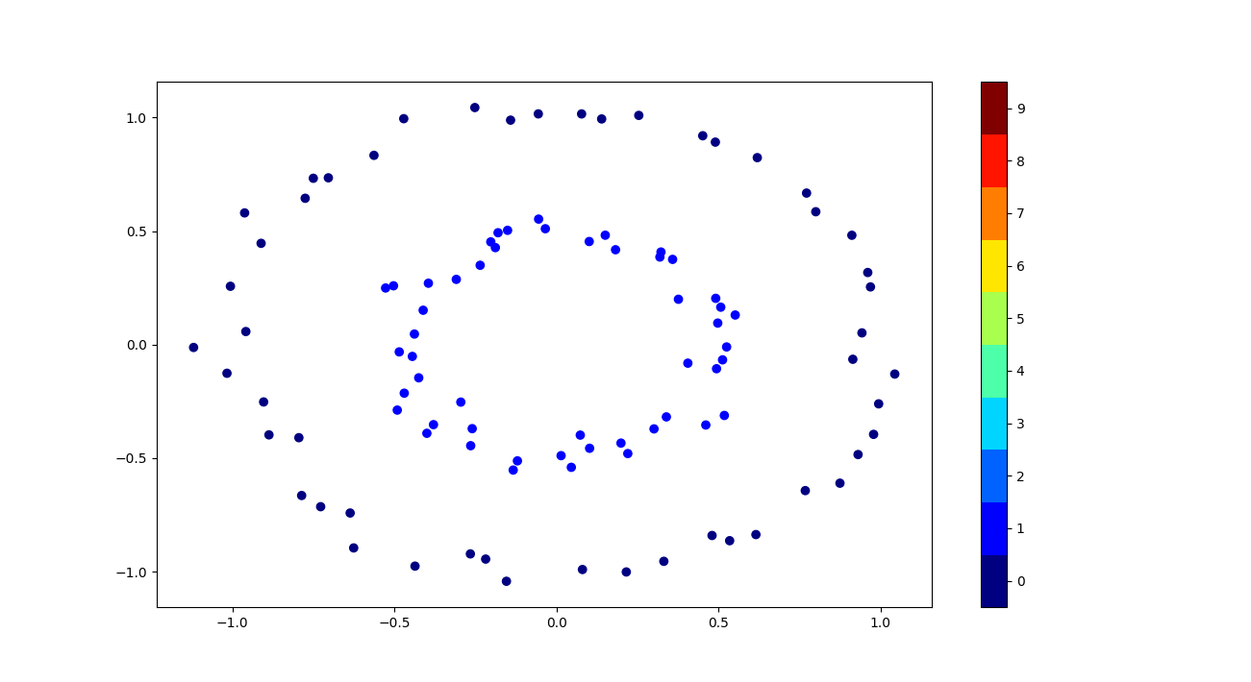
Dataset 2

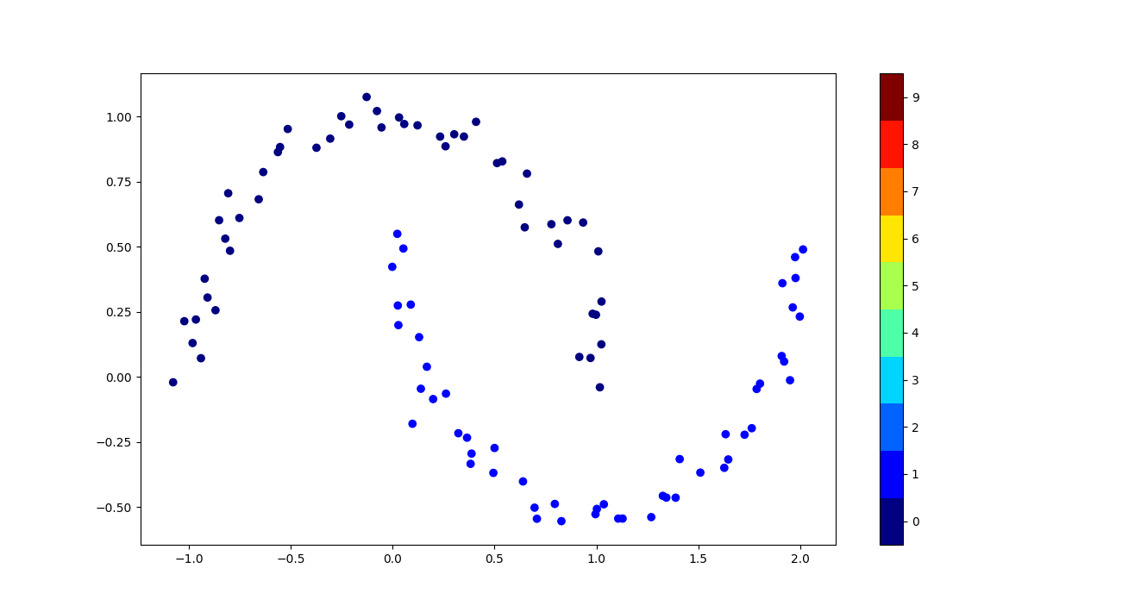

Dataset 3
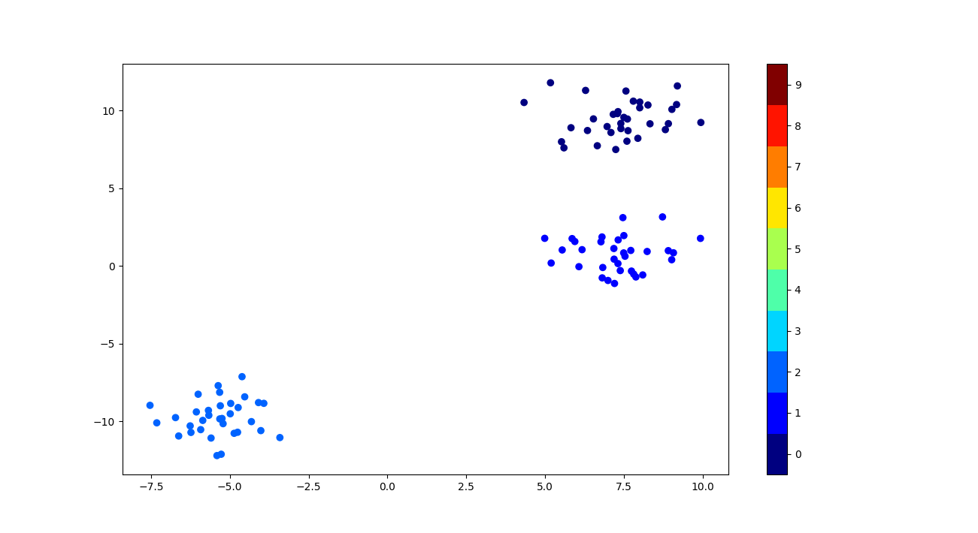
Dataset 4

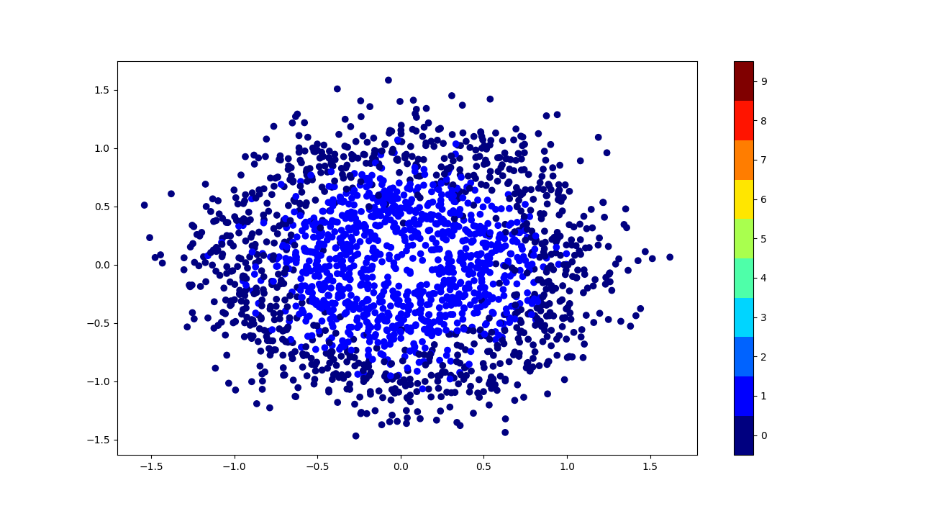

Dataset 5
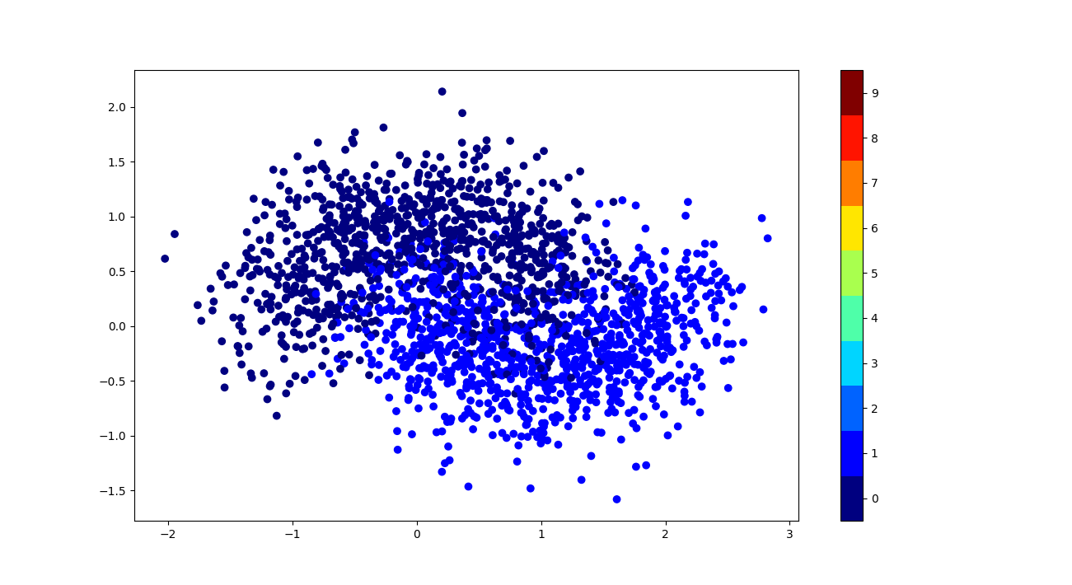

Q2:
Dataset 1
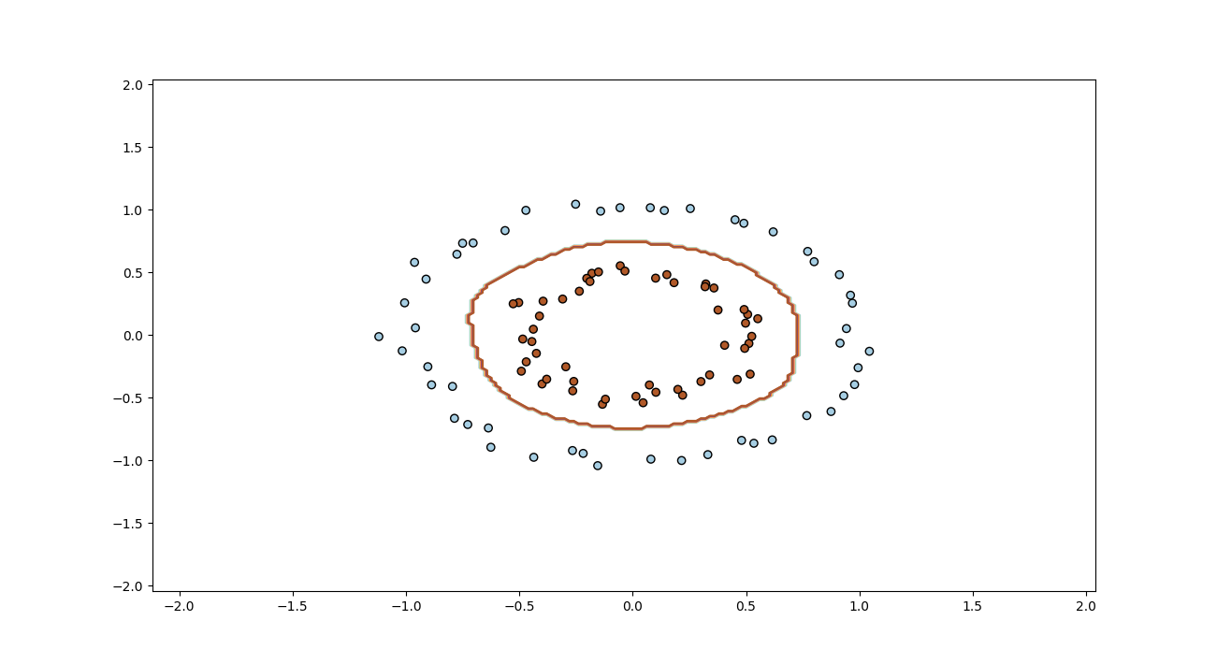
Choice of Kernel: RBF as it is not linearly seperable

Dataset 2

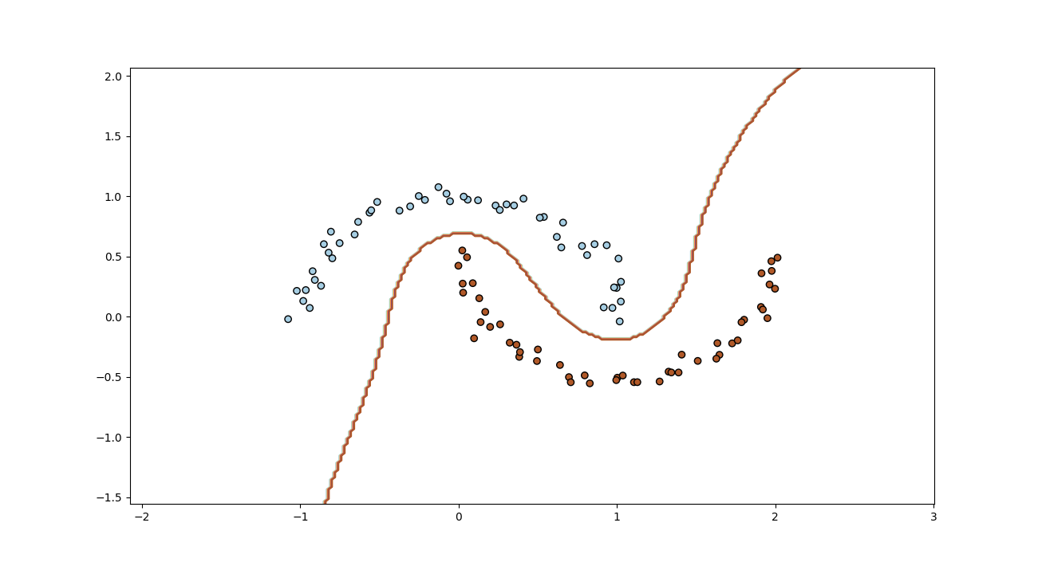
Choice of Kernel: RBF as it is not linearly seperable

Dataset 3

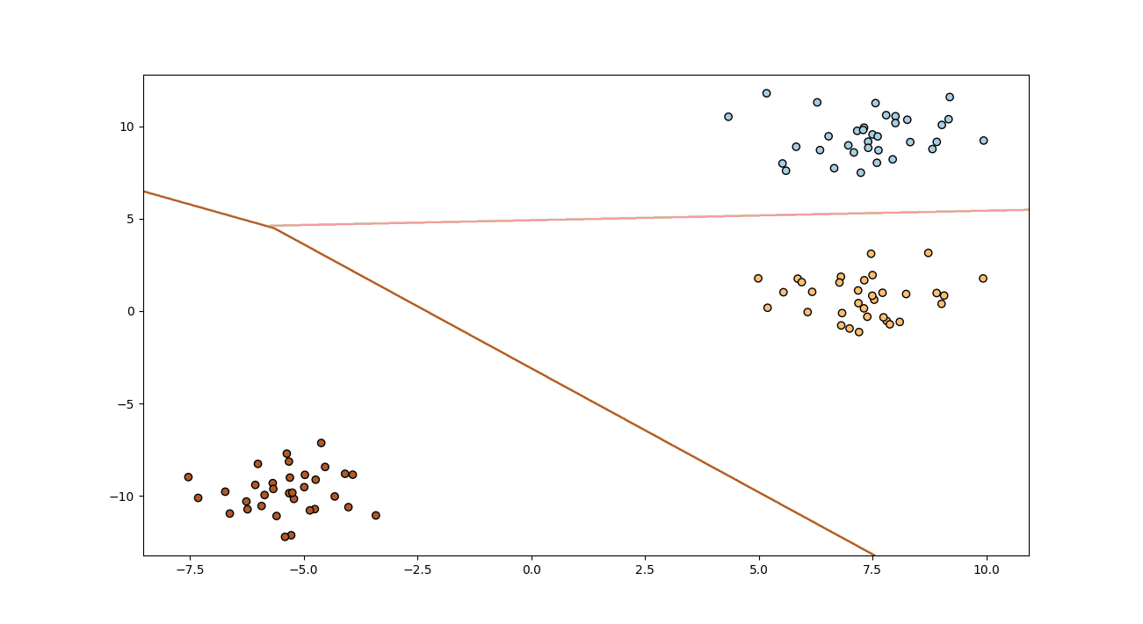
Choice of Kernel: Linear as they can be linearly seperated

Dataset 4

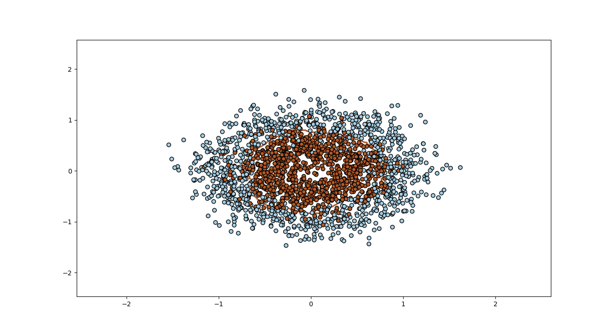
Choice of Kernel: RBF as it is not linearly seperable

Dataset 5

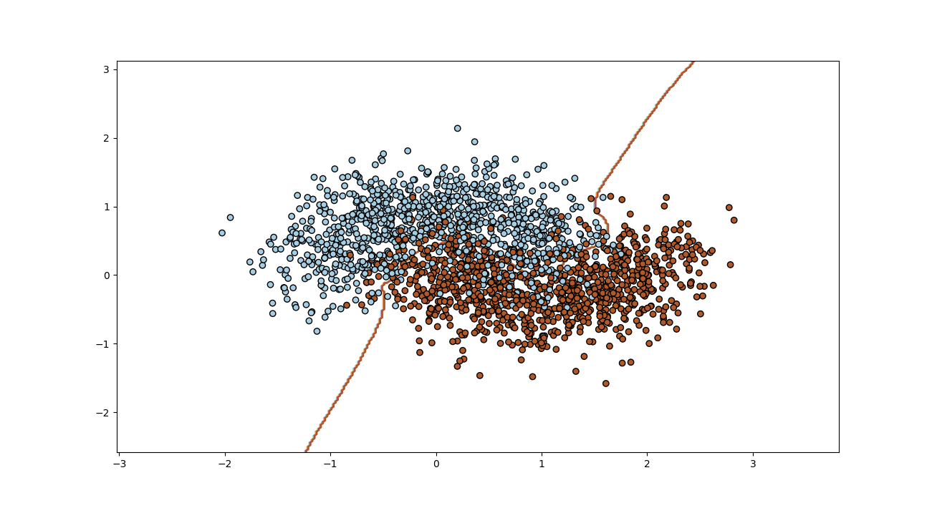
Choice of Kernel: RBF as it is not linearly seperable

Q3
Used Technique : modified z_score:
modified_z_scores = [0.6745 * (y - median) / median_absolute_deviation_y ]
Dataset 1

threshold x1=1 and x2=1

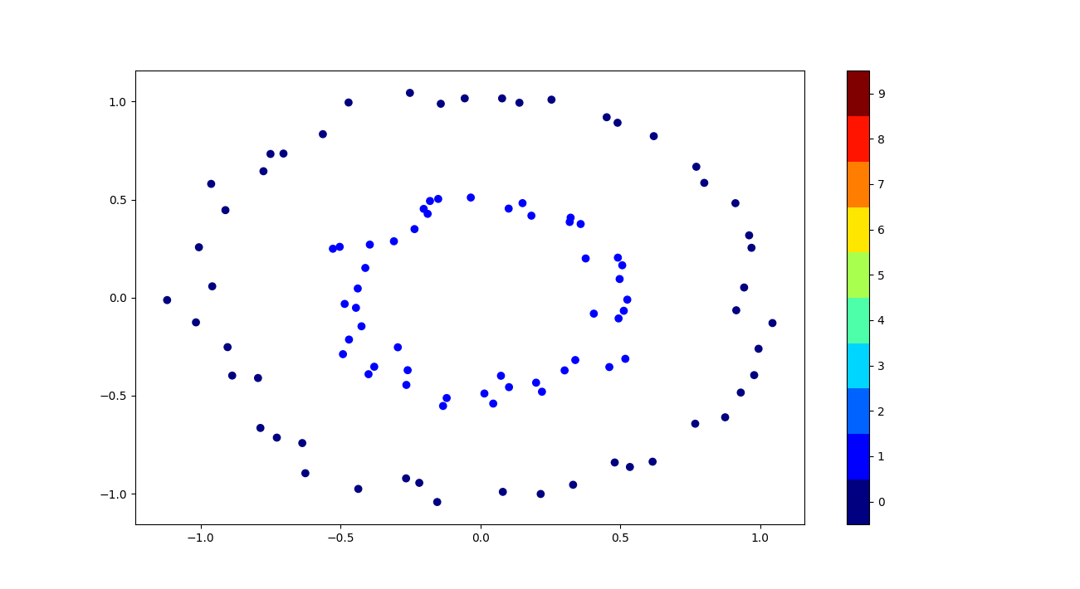

Dataset 2

threshold x1=2.4 and x2=1

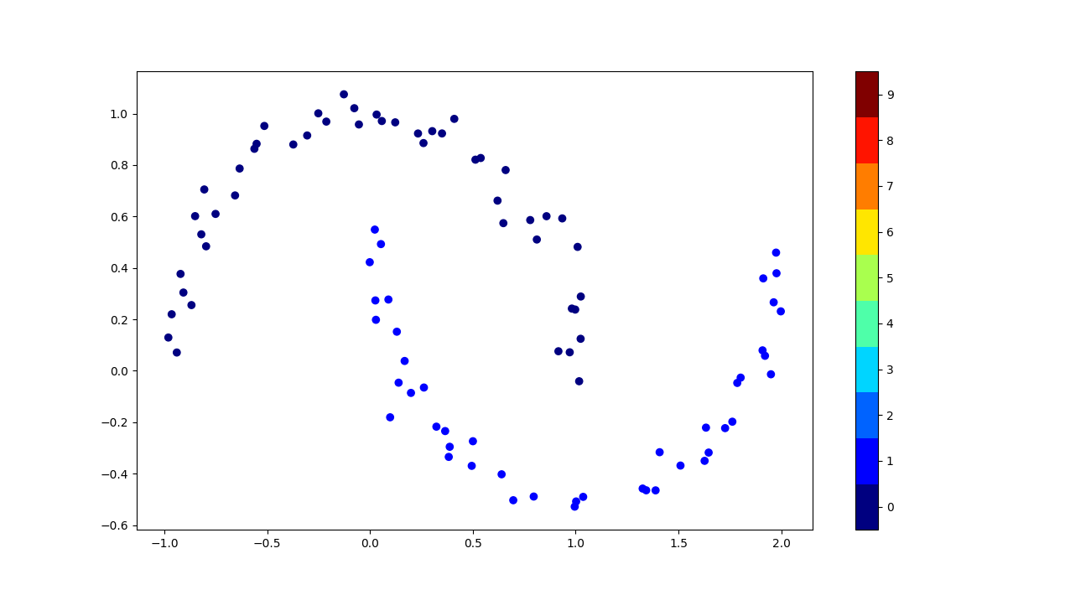

Dataset 3

threshold x1=1.1 and x2=2

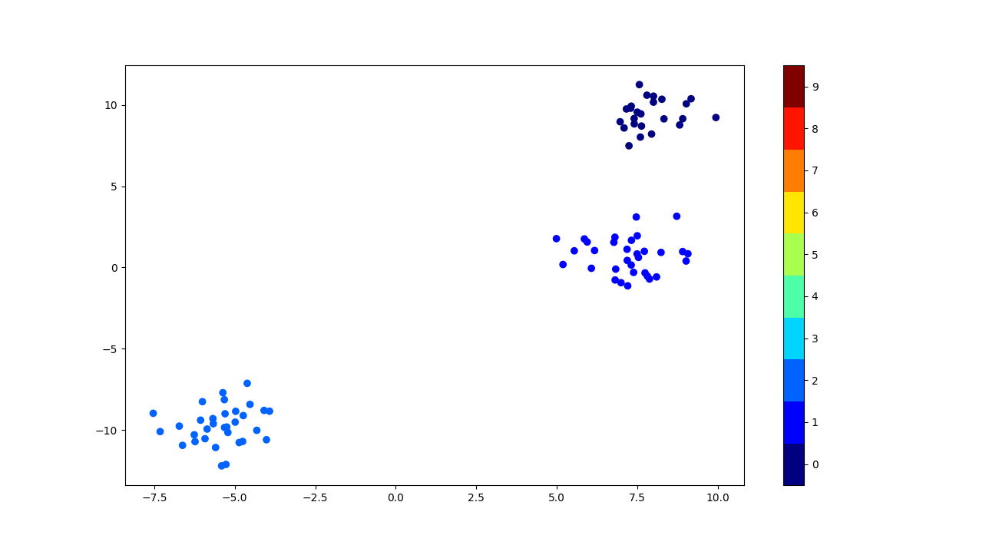

Dataset 4

threshold x1=1.5 and x2=1.5

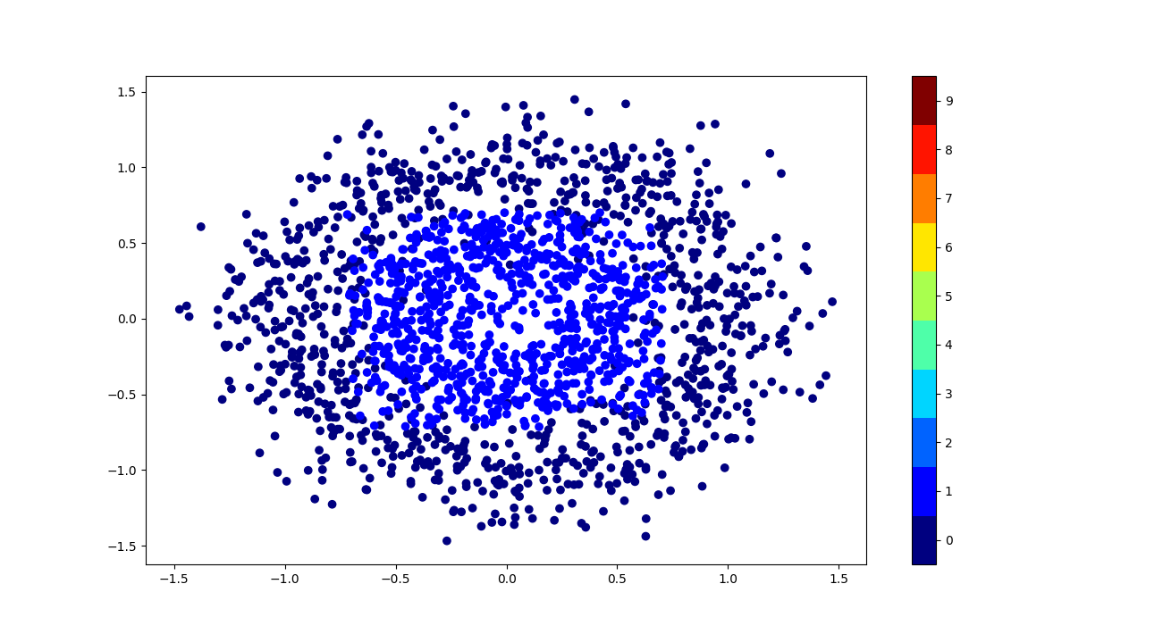

Dataset 5

threshold x1=1.8 and x2=1.4

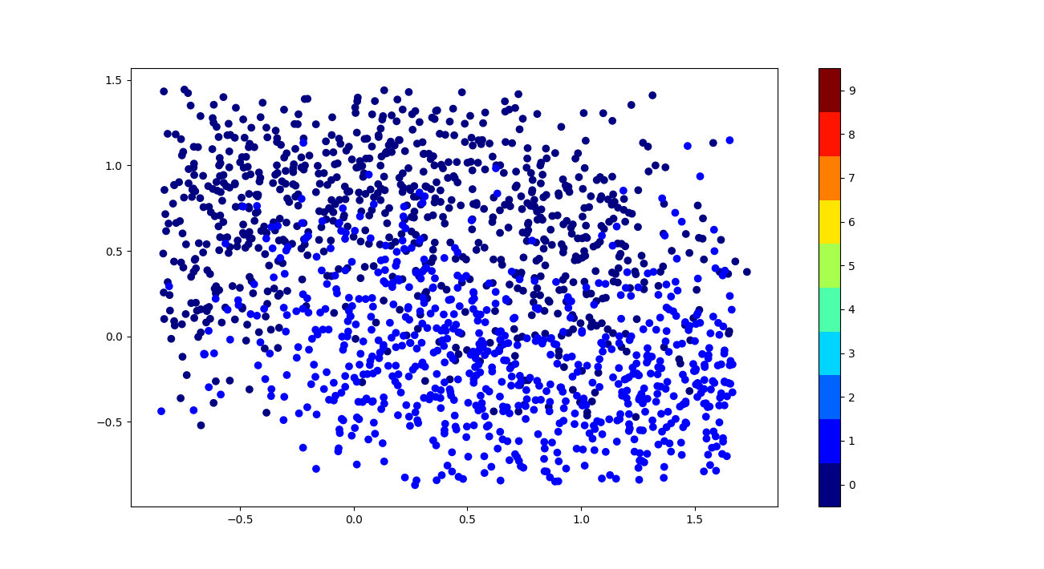

SVM

1. Linear kernel

Dataset 1:
One vs One

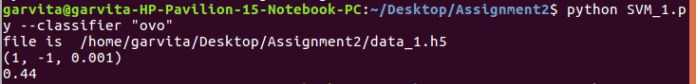
- Choice of hyperparameter C=1,max_iter=default,tol=.001
- Method to choice: grid search
- Linear SVM should not be preffered in this case ,either kernel svm or logistic regression should be used.
- Metrics used to compare is : accuracy which is coming as .44 in case of linear kernel which is very low

- Margin Seperating hyperplane and support vector

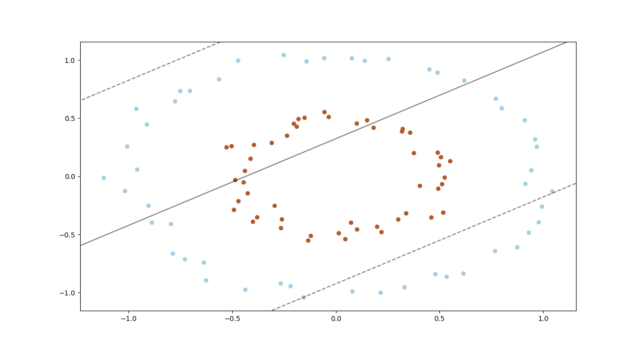
- Confusion Matrix:

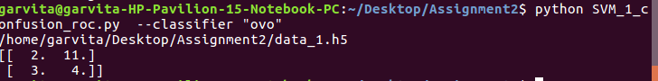
- ROC curve

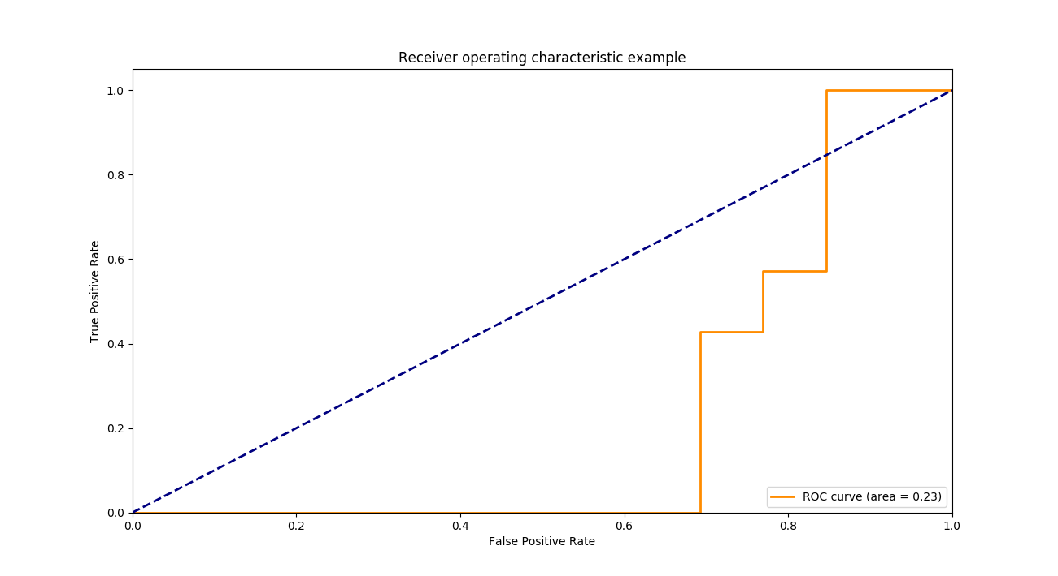

One vs Rest

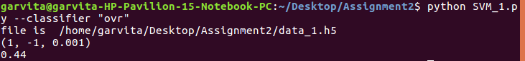
- Choice of hyperparameter C=1,max_iter=default,tol=.001
- Method to choice: grid search
- Linear SVM should not be preffered in this case ,either kernel svm or logistic regression should be used.
- Metrics used to compare is : accuracy which is coming as .44 in case of linear kernel which is very low

- Margin Seperating hyperplane and support vector

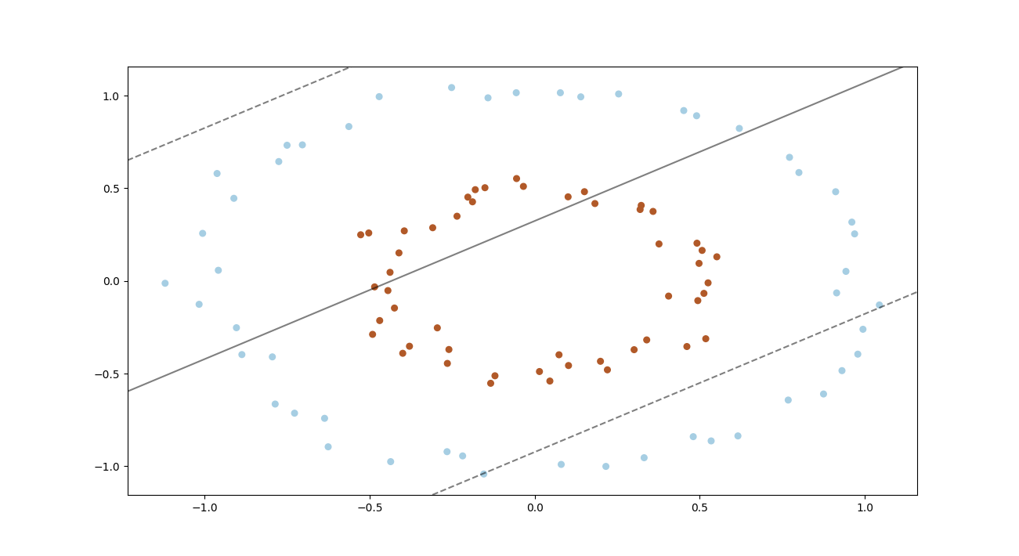

- Confusion Matrix:

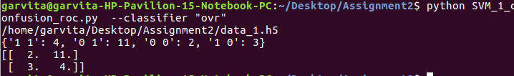

- ROC curve

Dataset 2

One vs One

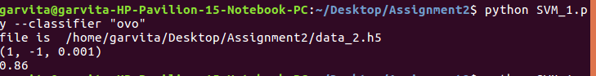
- Choice of hyperparameter C=1,max_iter=default,tol=.001
- Method to choice: grid search
- Linear SVM should not be preffered in this case ,either kernel (polynomial or rbf)svm or logistic regression should be used.
- Metrics used to compare is : accuracy score

- Margin Seperating hyperplane and support vector

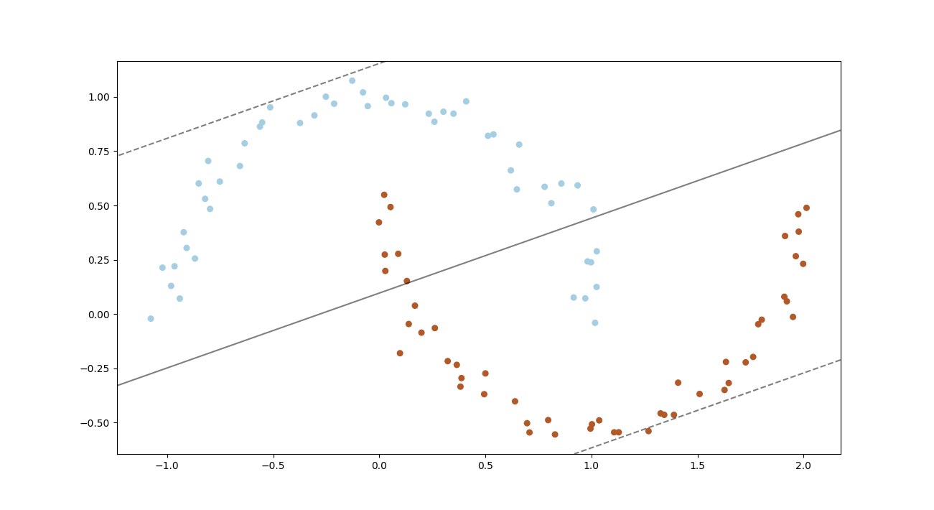

- Confusion Matrix:
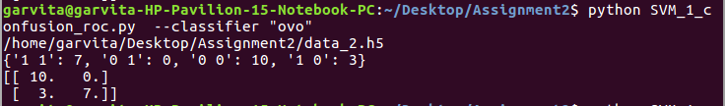

- ROC curve
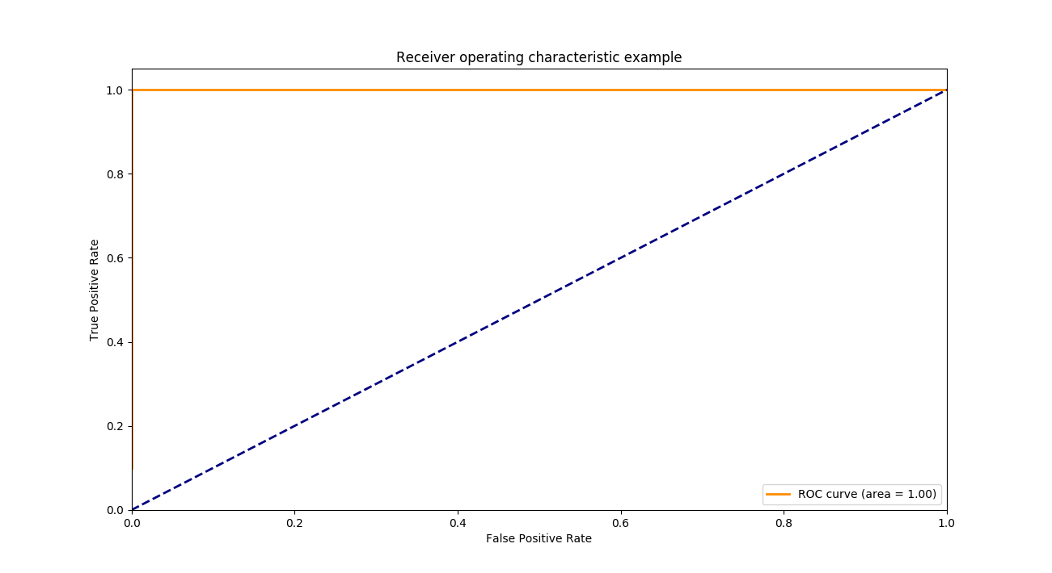
One vs Rest

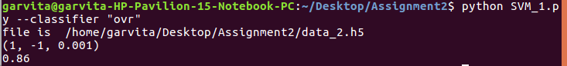
- Choice of hyperparameter C=1,max_iter=default,tol=.001
- Method to choice: grid search
- Linear SVM should not be preffered in this case ,either kernel (polynomial or rbf)svm or logistic regression should be used.
- Metrics used to compare is : accuracy score

- Margin Seperating hyperplane and support vector

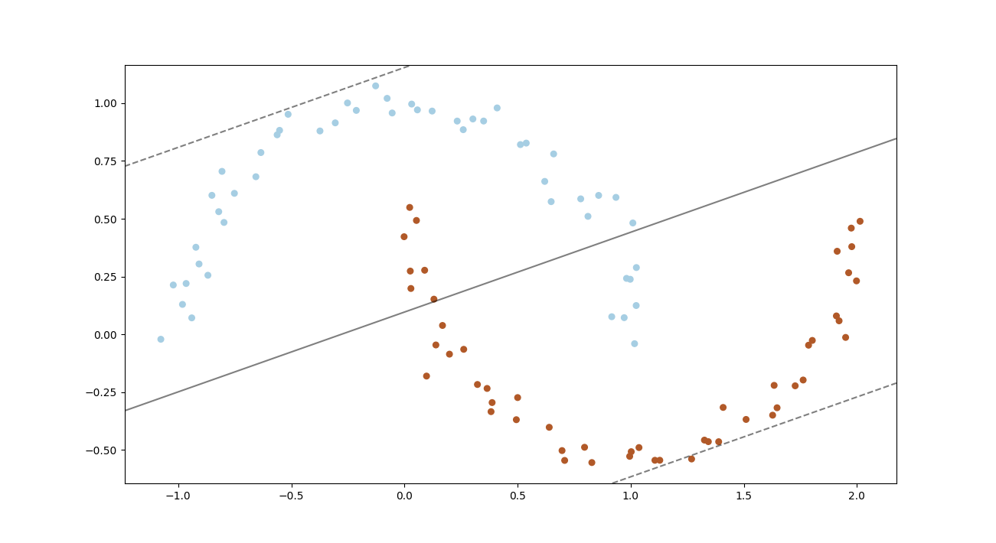
- Confusion Matrix:

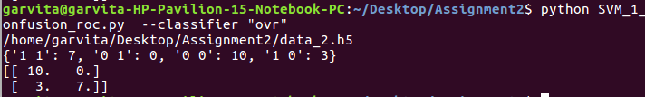

- ROC curve

Dataset 3

One vs One

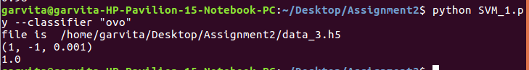
- Choice of hyperparameter C=1,max_iter=default,tol=.001
- Method to choice: grid search
- Linear SVM should be preffered in this case
- Metrics used to compare is : accuracy score

- Margin Seperating hyperplane and support vector
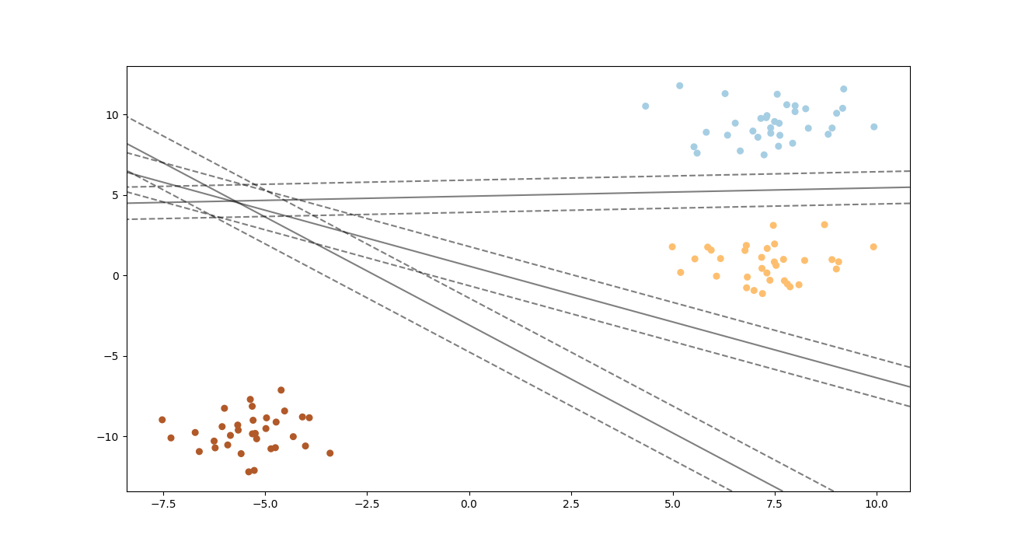

- Confusion Matrix:

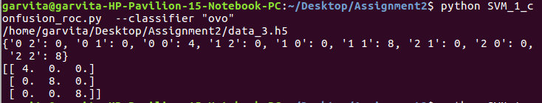

One vs Rest

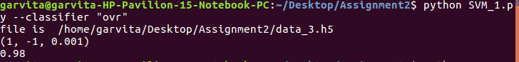
- Choice of hyperparameter C=1,max_iter=default,tol=.001
- Method to choice: grid search
- Linear SVM should be preffered in this case
- Metrics used to compare is : accuracy score

- Margin Seperating hyperplane and support vector

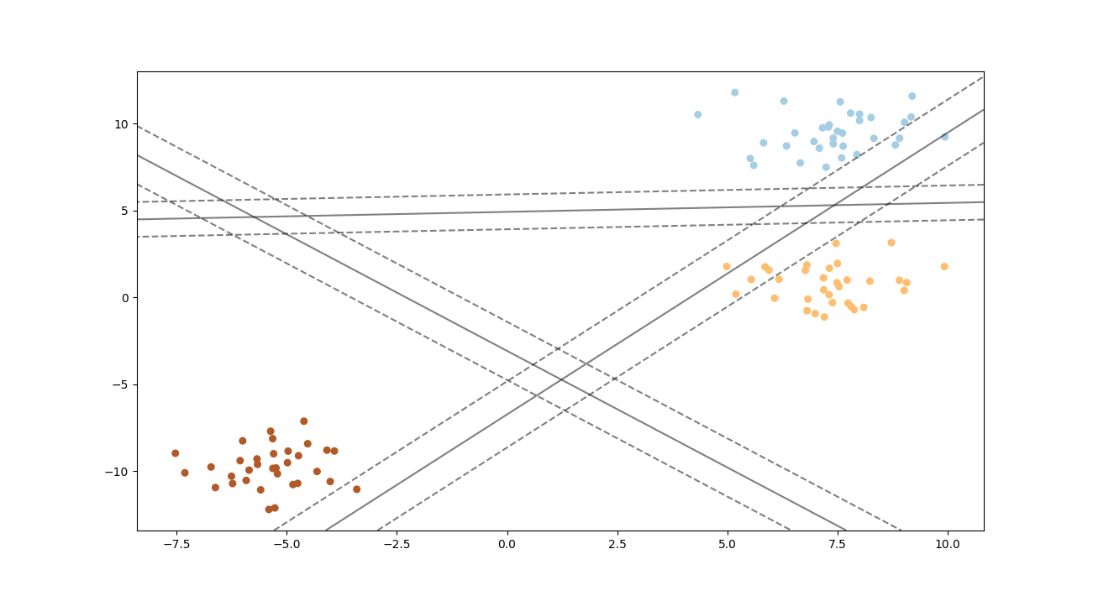
- Confusion Matrix:
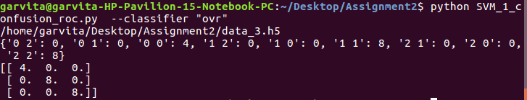

Dataset 4:

One vs One

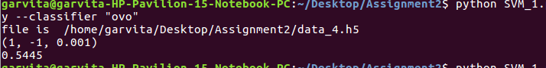
- Choice of hyperparameter C=1,max_iter=default,tol=.001
- Method to choice: grid search
- Linear SVM should not be preffered in this case ,either kernel ( rbf) svm or logistic regression should be used.
- Metrics used to compare is : accuracy score

- Margin Seperating hyperplane and support vector

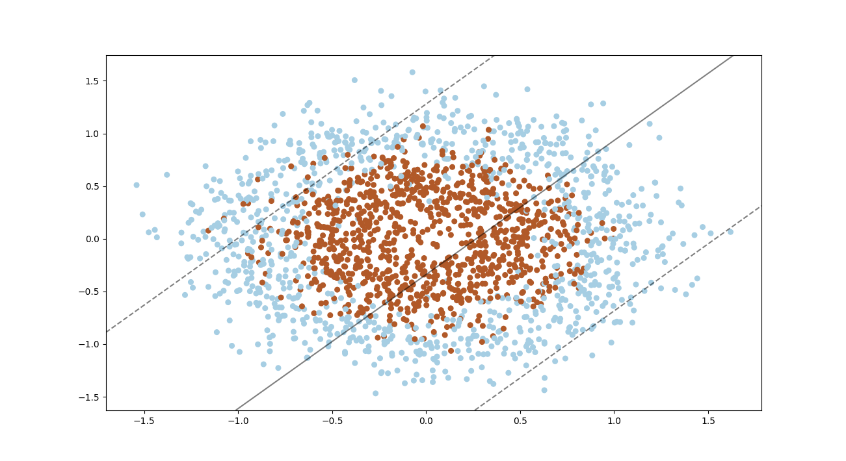
- Confusion Matrix
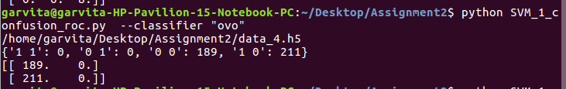

- ROC curve
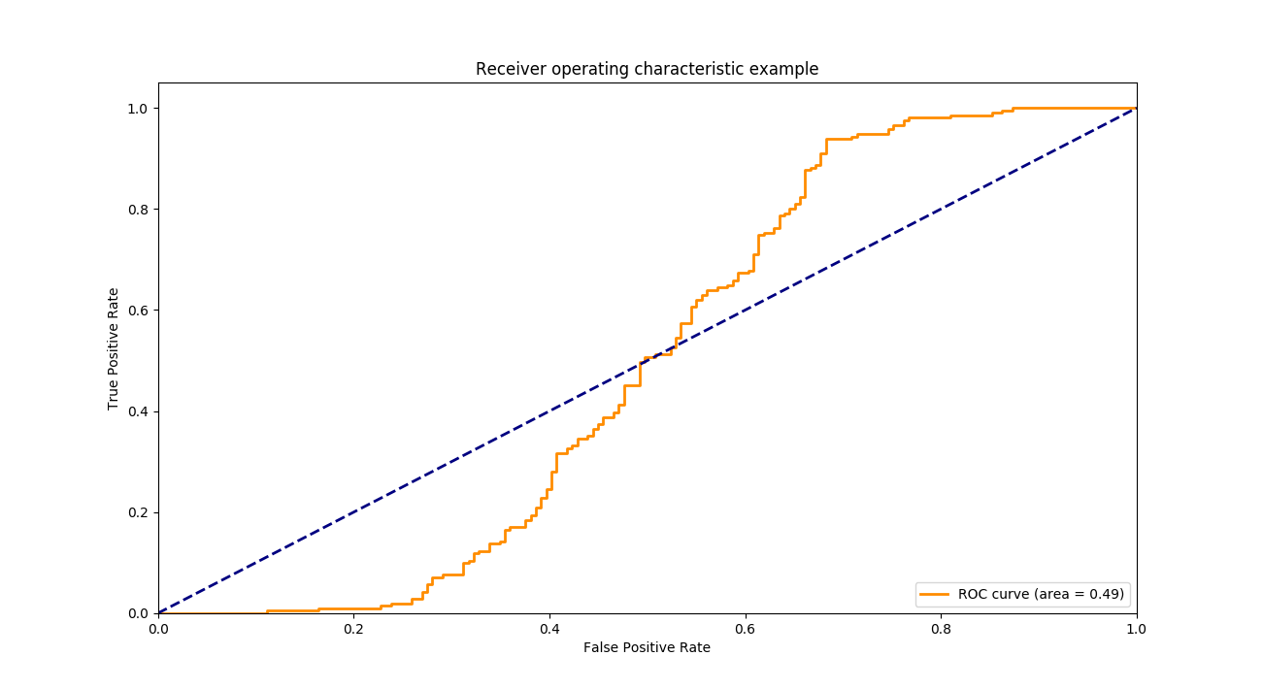
One vs Rest

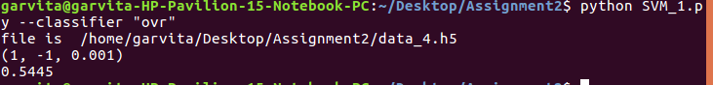
- Choice of hyperparameter C=1,max_iter=default,tol=.001
- Method to choice: grid search
- Linear SVM should not be prefered in this case ,either kernel ( rbf) svm or logistic regression should be used.
- Metrics used to compare is : accuracy score

- Margin Seperating hyperplane and support vector

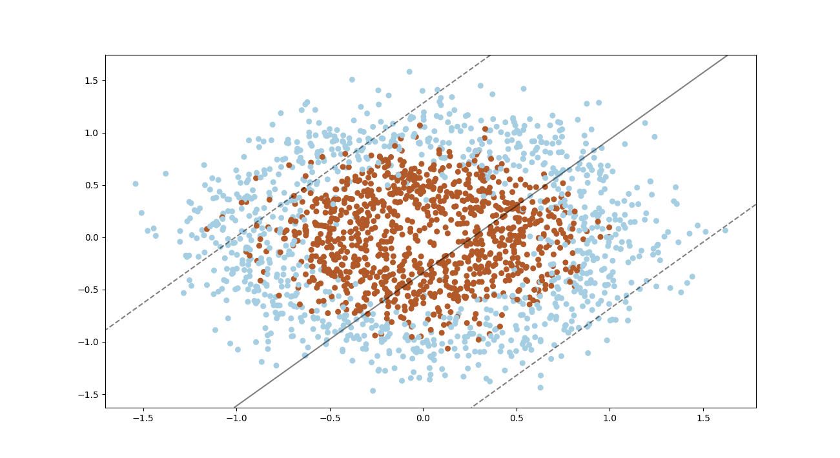

- Confusion Matrix
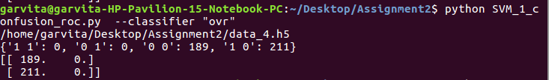

- ROC curve

Dataset 5

One vs One

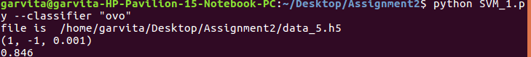
- Choice of hyperparameter C=1,max_iter=default,tol=.001
- Method to choice: grid search
- Linear SVM can be prefered in this case(but not a good choice) ,either kernel ( polynomial) svm or logistic regression should be used.
- Metrics used to compare is : accuracy score

- Margin Seperating hyperplane and support vector
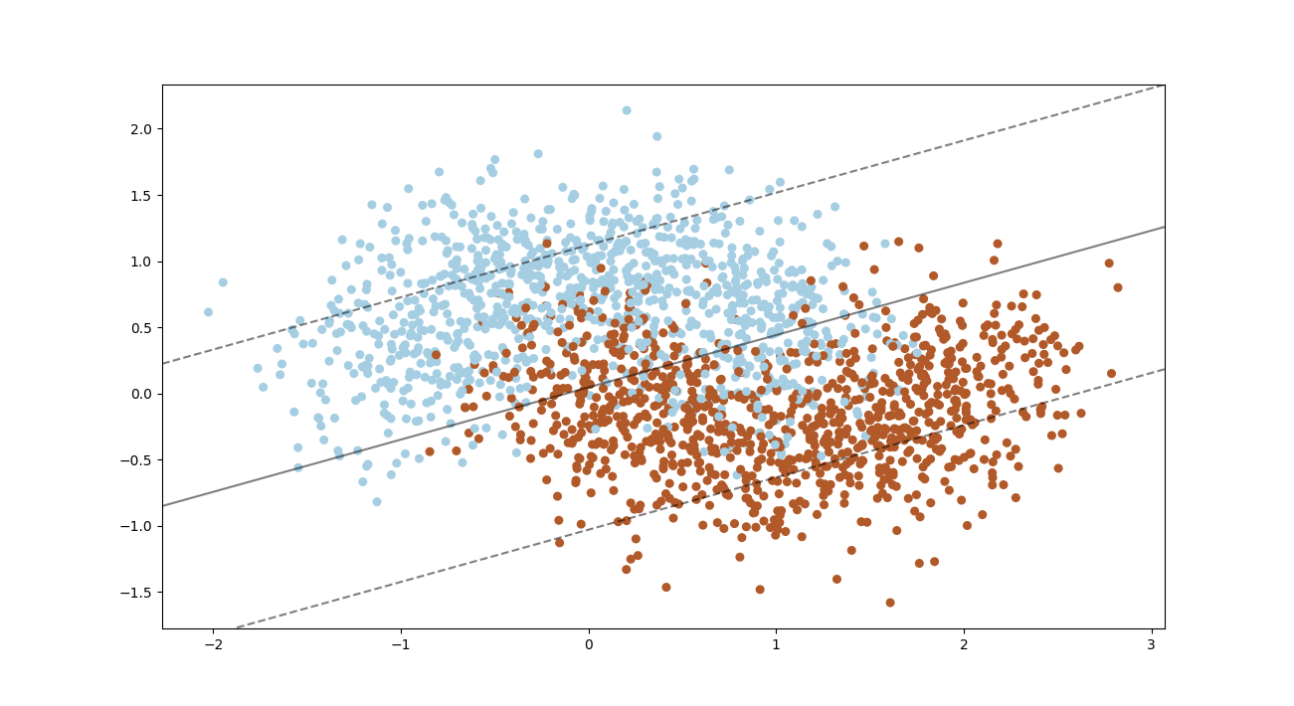
- Confusion metrics
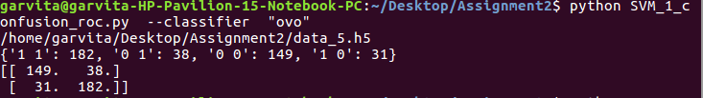
- ROC Curve

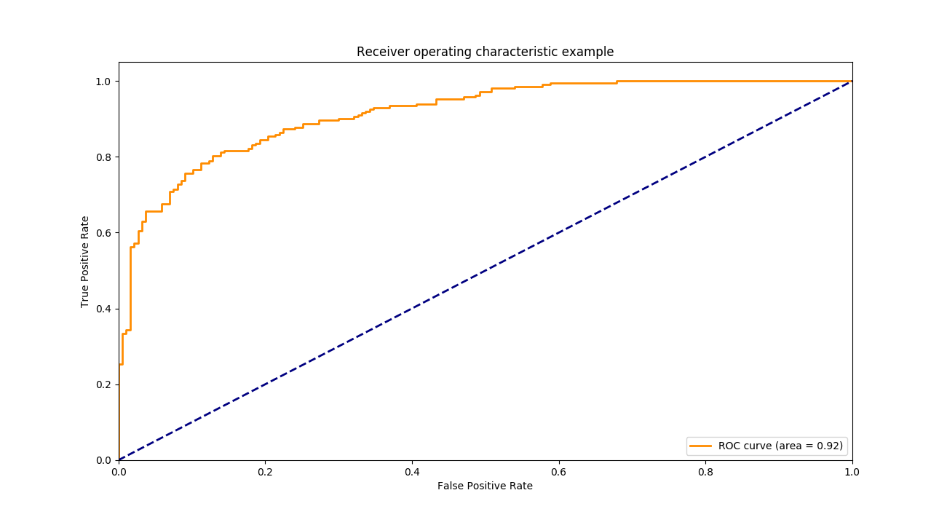

One vs Rest

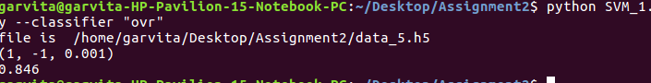

- Choice of hyperparameter C=1,max_iter=default,tol=.001
- Method to choice: grid search
- Linear SVM can be prefered in this case(but not a good choice) ,either kernel ( polynomial) svm or logistic regression should be used.
- Metrics used to compare is : accuracy score

- Margin Seperating hyperplane and support vector

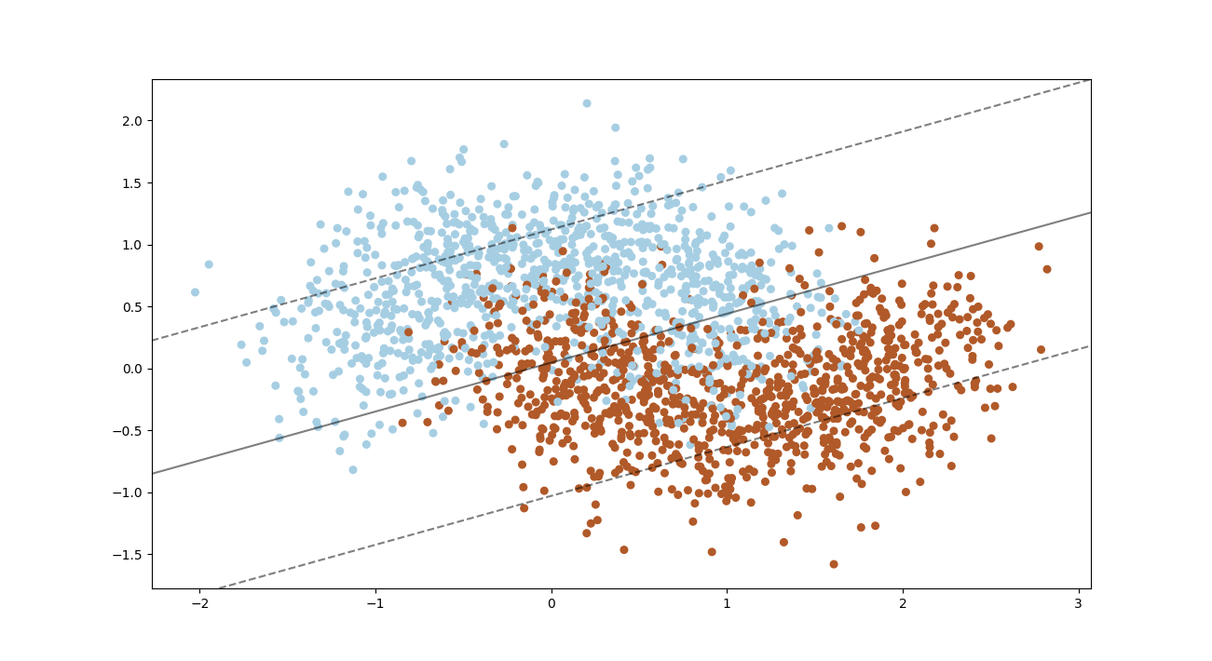
- Confusion Metrics

- ROC curve

Previous datasets:
Part A

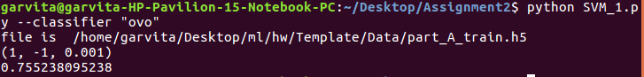
- Choice of hyperparameter C=1,max_iter=default,tol=.001
- Method to choice: grid search
- Logistic Regression should be used over linear svm as in LR accuracy obtained was .877(in previous assignment).
- Metrics used to compare is : accuracy score

- Margin Seperating hyperplane and support vector

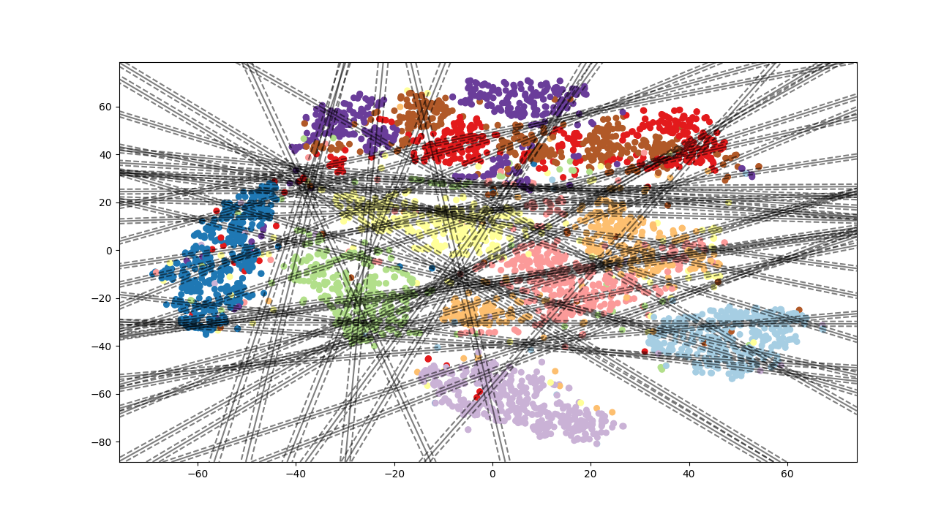

- Confusion Metrics
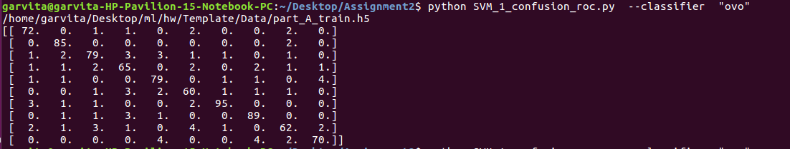

One vs rest
- Margin Seperating hyperplane and support vector

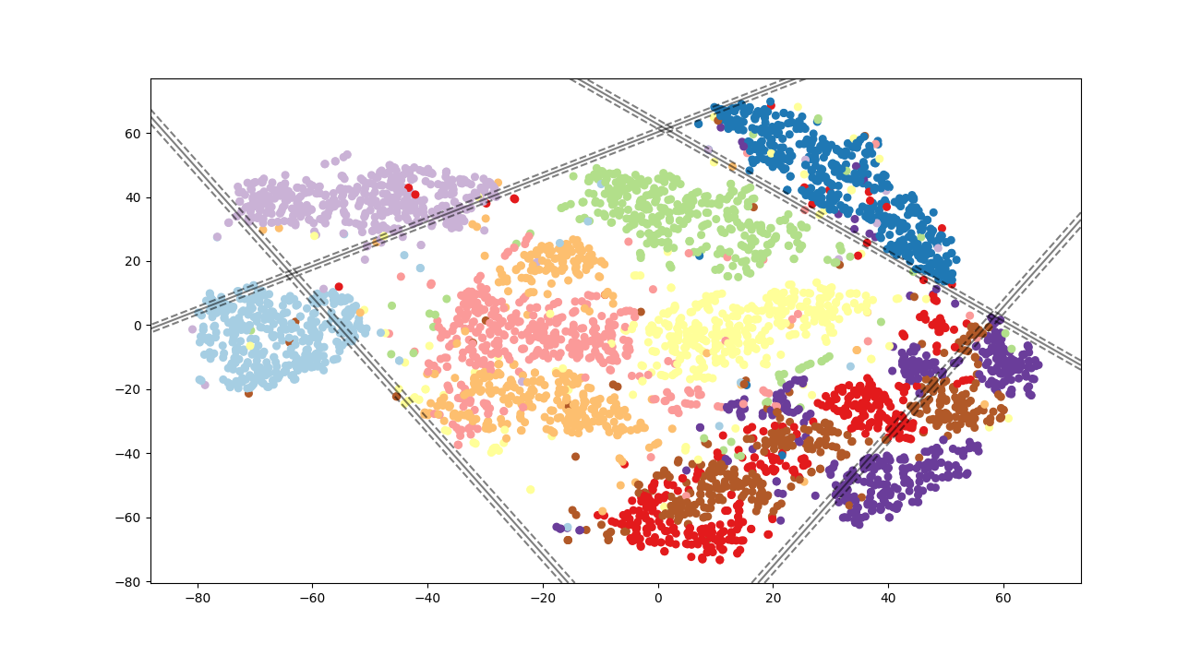
- Confusion Matrix
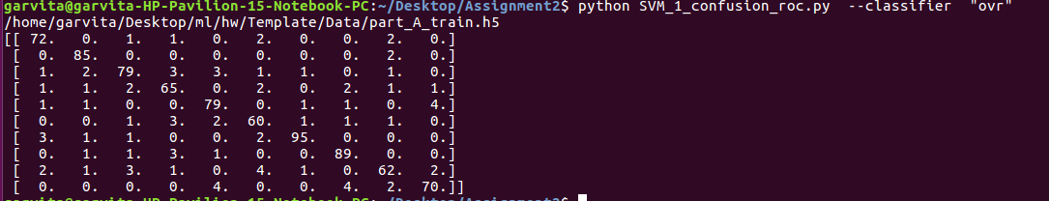

Part B
One vs One

- Margin Seperating hyperplane and support vector

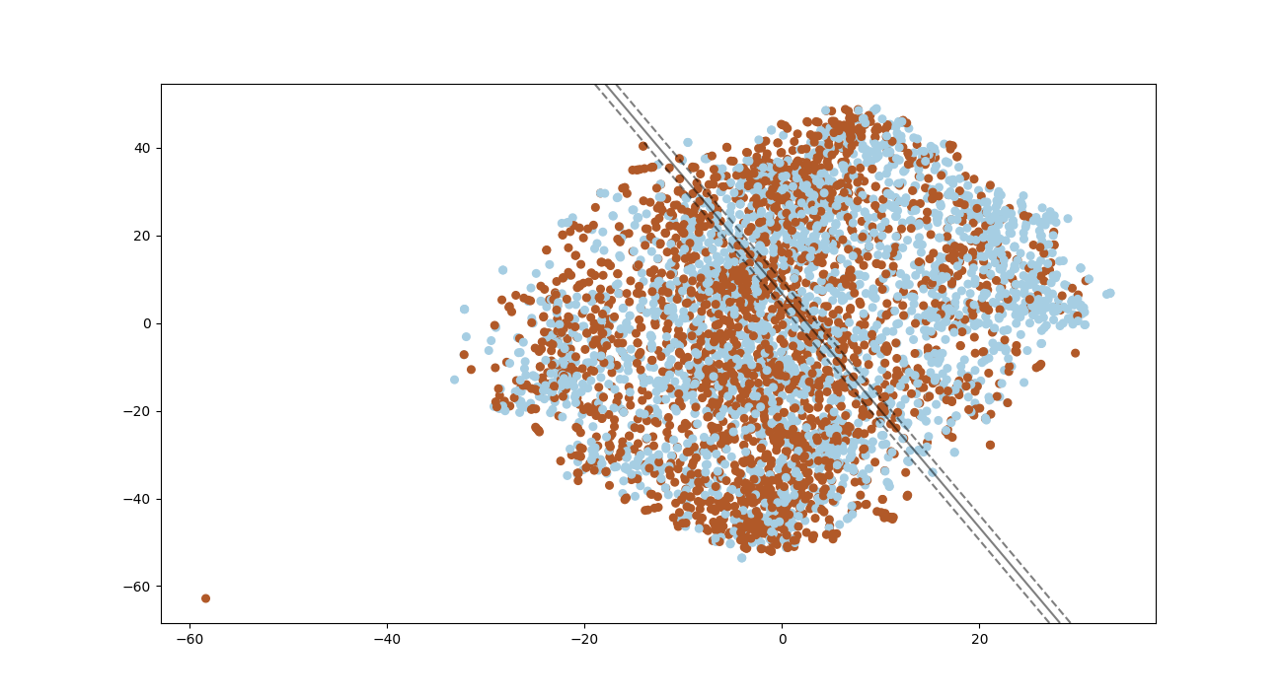
- Confusion matrix

- ROC curve
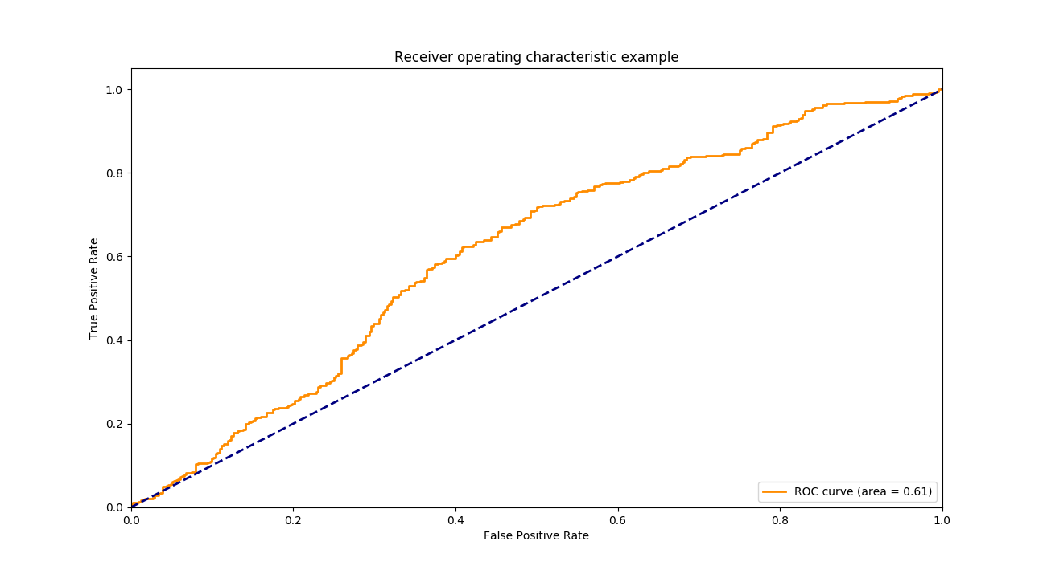

One vs Rest

- Margin Seperating hyperplane and support vector

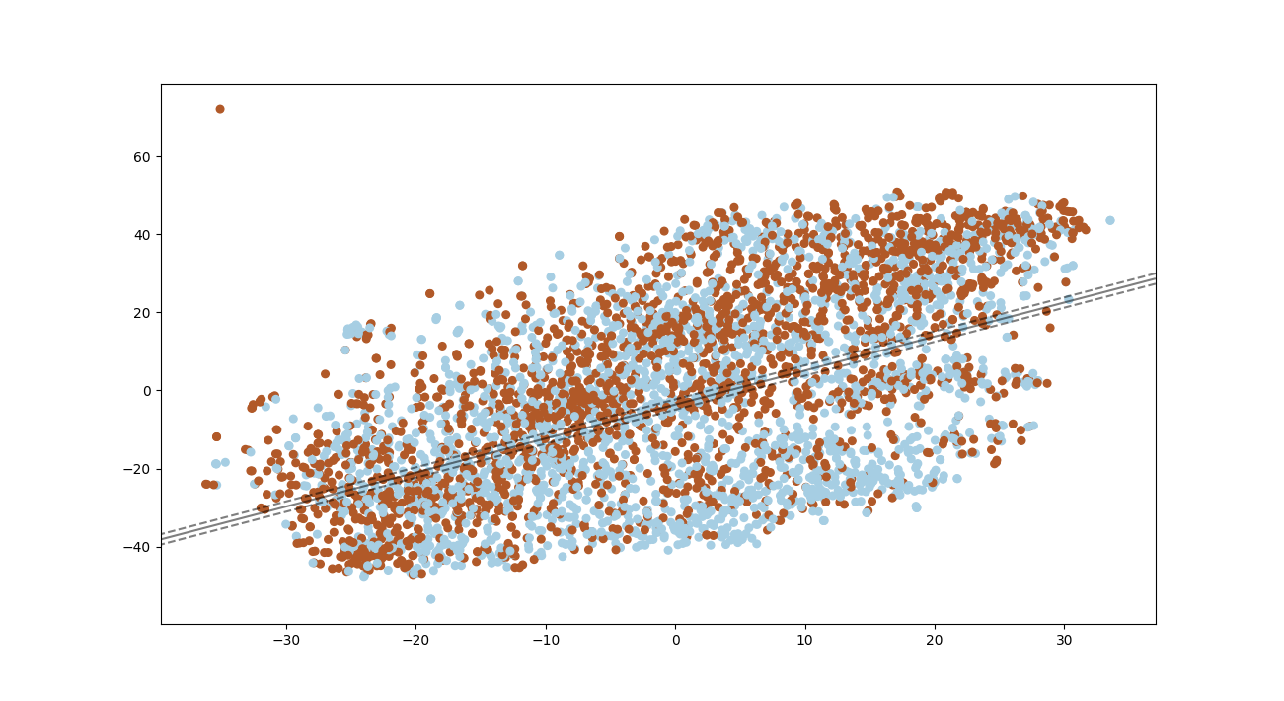

- Confusion Matrix:
- ROC curve:

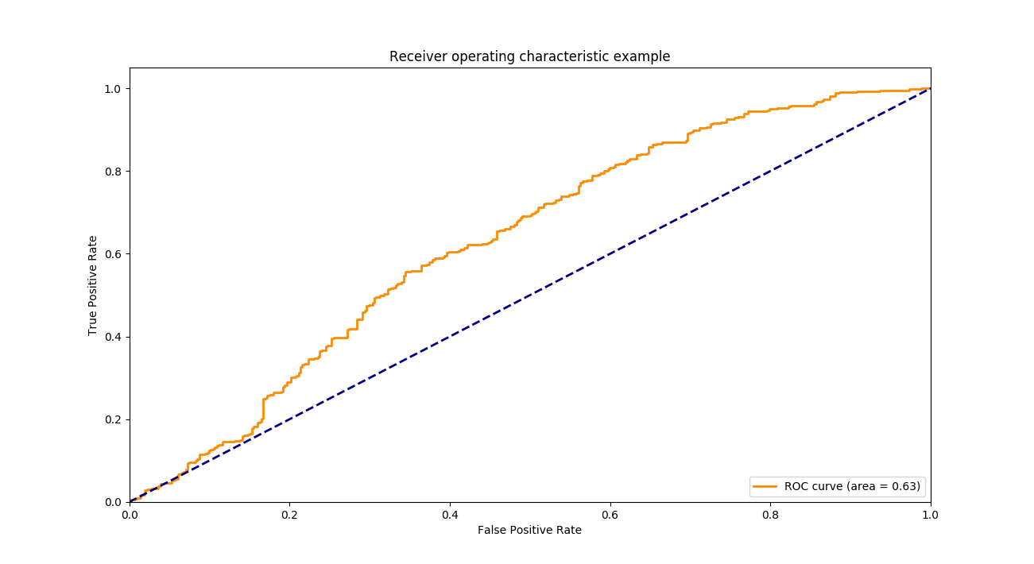

Part C

One vs One

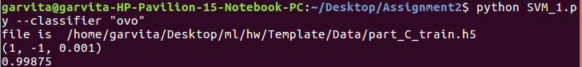
- Choice of hyperparameter C=1,max_iter=default,tol=.001
- Method to choice: grid search
- Logistic Regression should be used as data is linearly seperable
- Metrics used to compare is : accuracy score

- Margin Seperating hyperplane and support vector

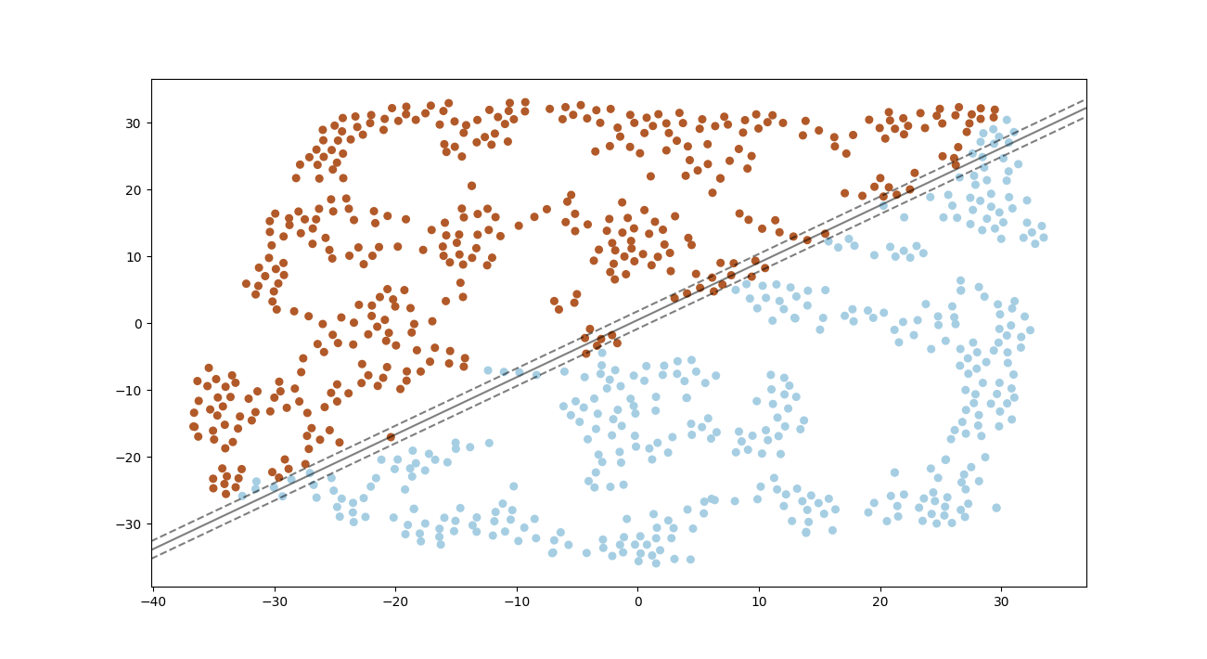
- Confusion Matrix:

- ROC curve

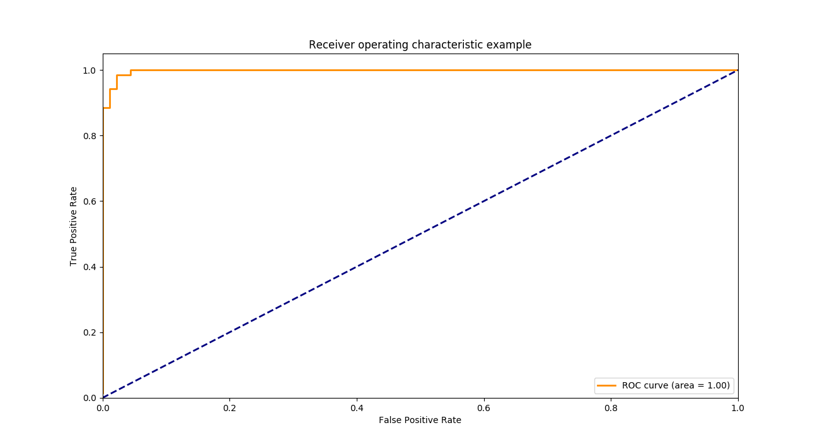
One vs Rest

- Margin Seperating hyperplane and support vector

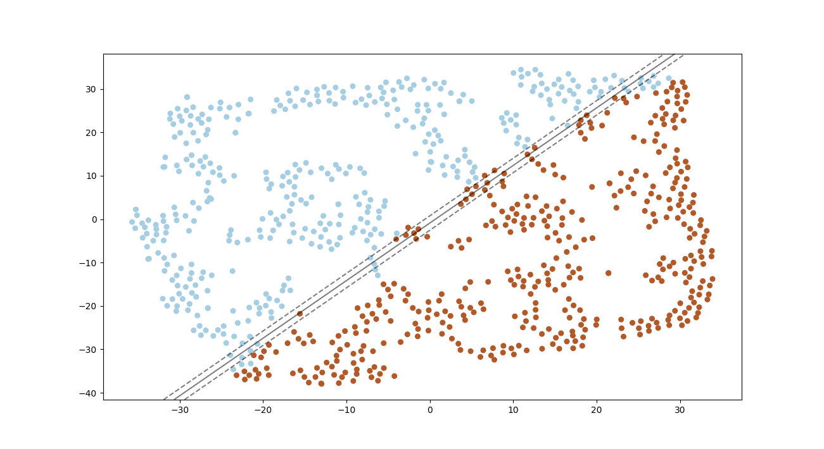

- Confusion Matrix:
- ROC curve

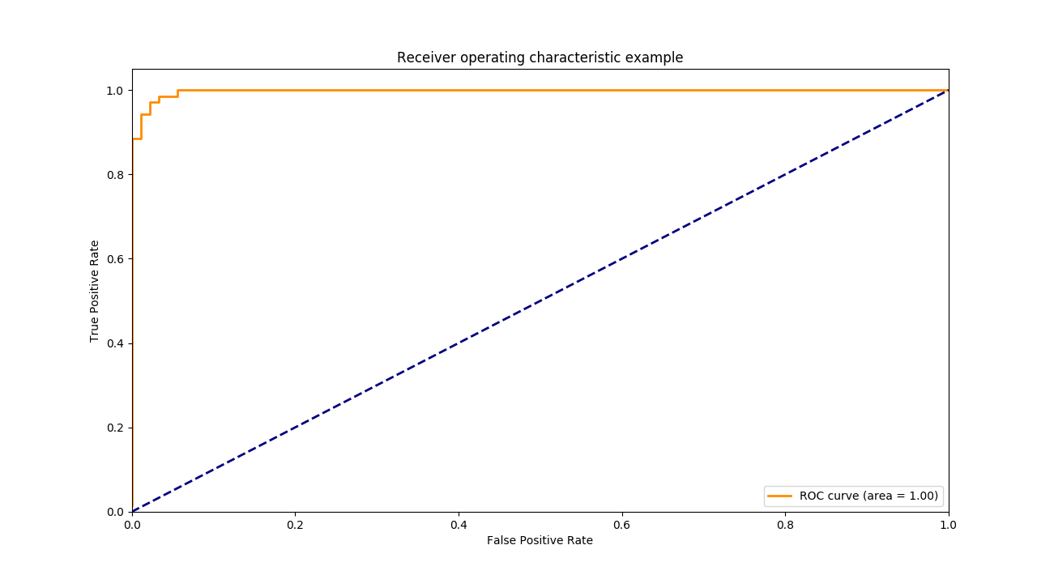

2. RBF Kernel

Dataset 1

One vs One

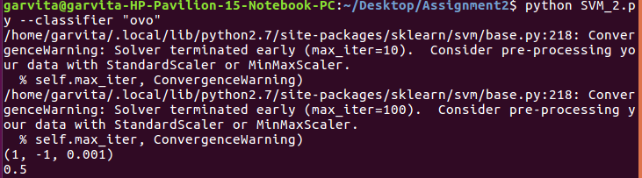

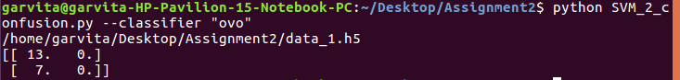

One vs Rest

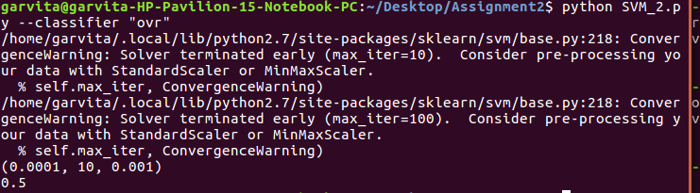
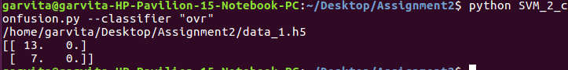

Dataset 2

One vs One
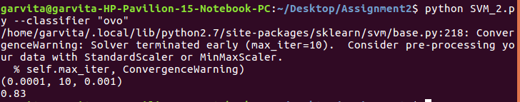
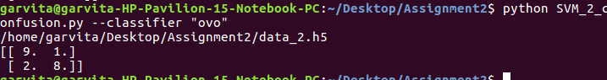

One vs Rest

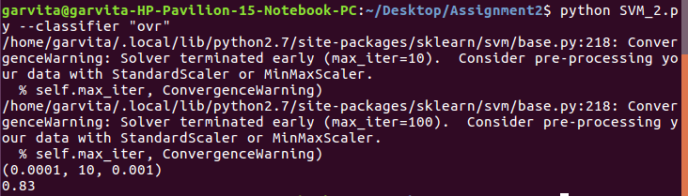
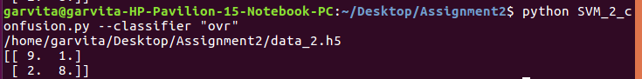
Dataset 3
One vs One

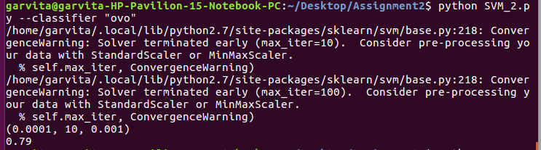

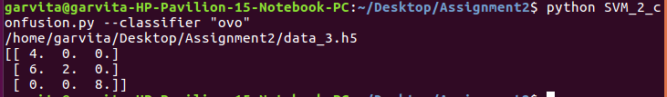
One vs Rest
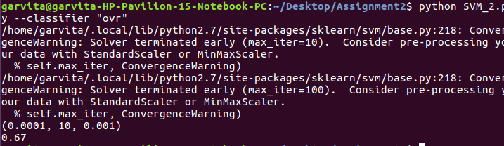

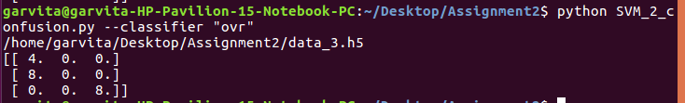

Dataset 4
One vs One
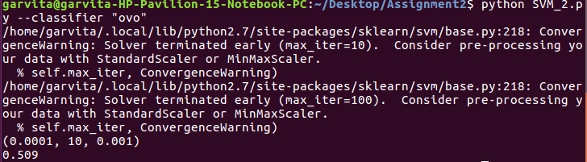

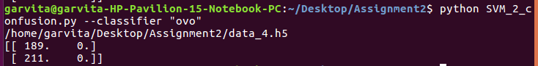
One vs Rest
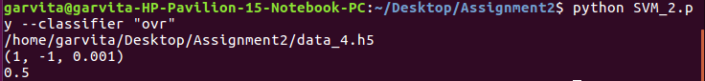

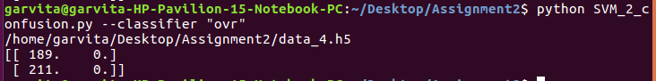
Dataset 5

One vs One

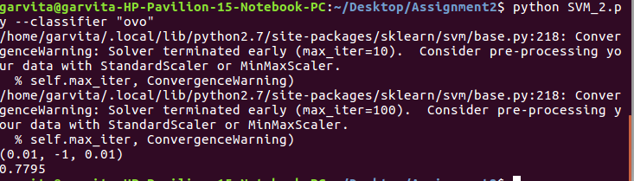
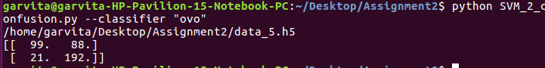

ROC Curve:

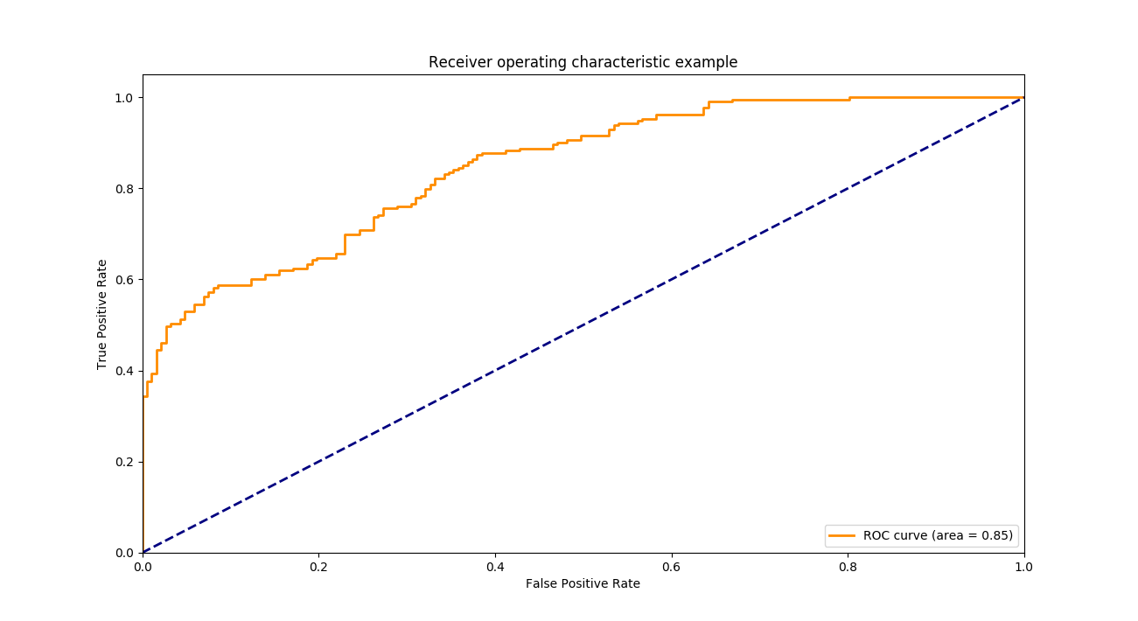

One vs Rest

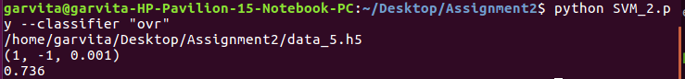
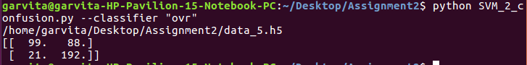

Theory​ ​ Questions​ ​

1.
Consider​ ​ the​ ​ RBF​ ​ kernel:​ ​ it​ ​ can​ ​ map​ ​ the​ ​ given​ ​ data​ ​ into​ ​ a ​ ​ higher​ ​ dimensional
space,​ ​ with​ ​ possibly​ ​ infinite​ ​ dimensions.​ ​ There​ ​ are​ ​ two​ ​ ways​ ​ to​ ​ look​ ​ at​ ​ it:​ ​ one​ ​ way
is​ ​ that​ ​ every​ ​ data​ ​ points​ ​ gets​ ​ its​ ​ own​ ​ dimension,​ ​ which​ ​ would​ ​ lead​ ​ to​ ​ overfitting.
However,​ ​ in​ ​ reality,​ ​ this​ ​ generally​ ​ does​ ​ not​ ​ happen.​ ​ Why?

Ans: It doesn’t lead to overfitting because it uses regularization and it reduces the chance of overfitting.Choosing right value of C(should be low) and gamma prevent data from being overfitted.

2. Show​ ​ that,​ ​ irrespective​ ​ of​ ​ the​ ​ dimensionality​ ​ of​ ​ the​ ​ data​ ​ space,​ ​ a ​ ​ data​ ​ set
consisting​ ​ of​ ​ just​ ​ two​ ​ data​ ​ points,​ ​ one​ ​ from​ ​ each​ ​ class,​ ​ is​ ​ sufficient​ ​ to​ ​ determine
the​ ​ location​ ​ of​ ​ the​ ​ maximum-margin​ ​ hyperplane.​ ​ You​ ​ are​ ​ expected​ ​ to​ ​ give​ ​ a
mathematical​ ​ proof.

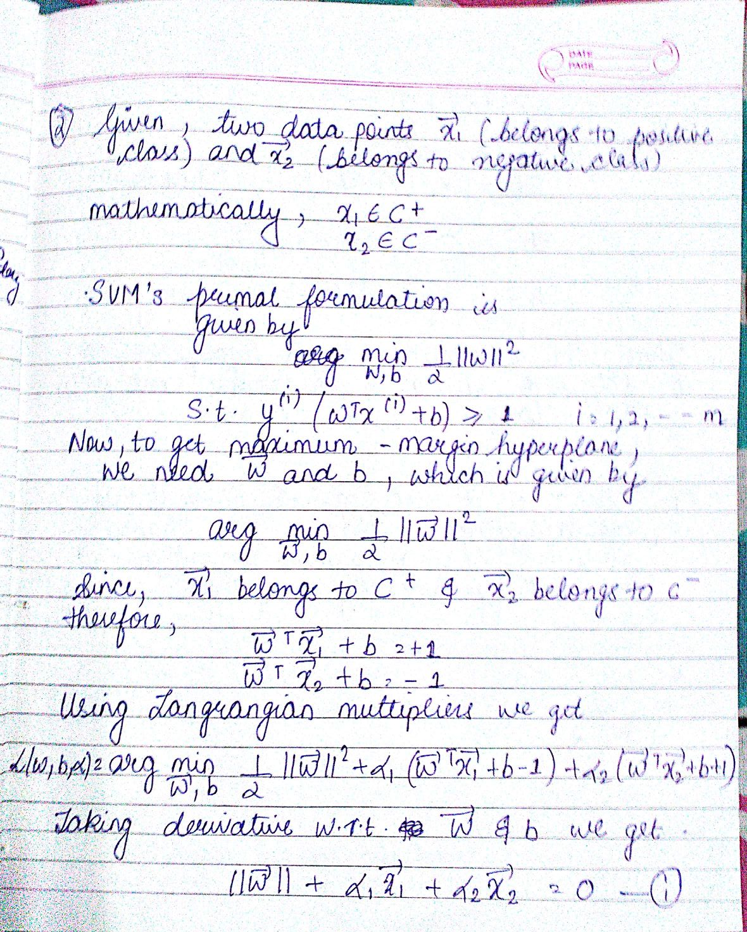

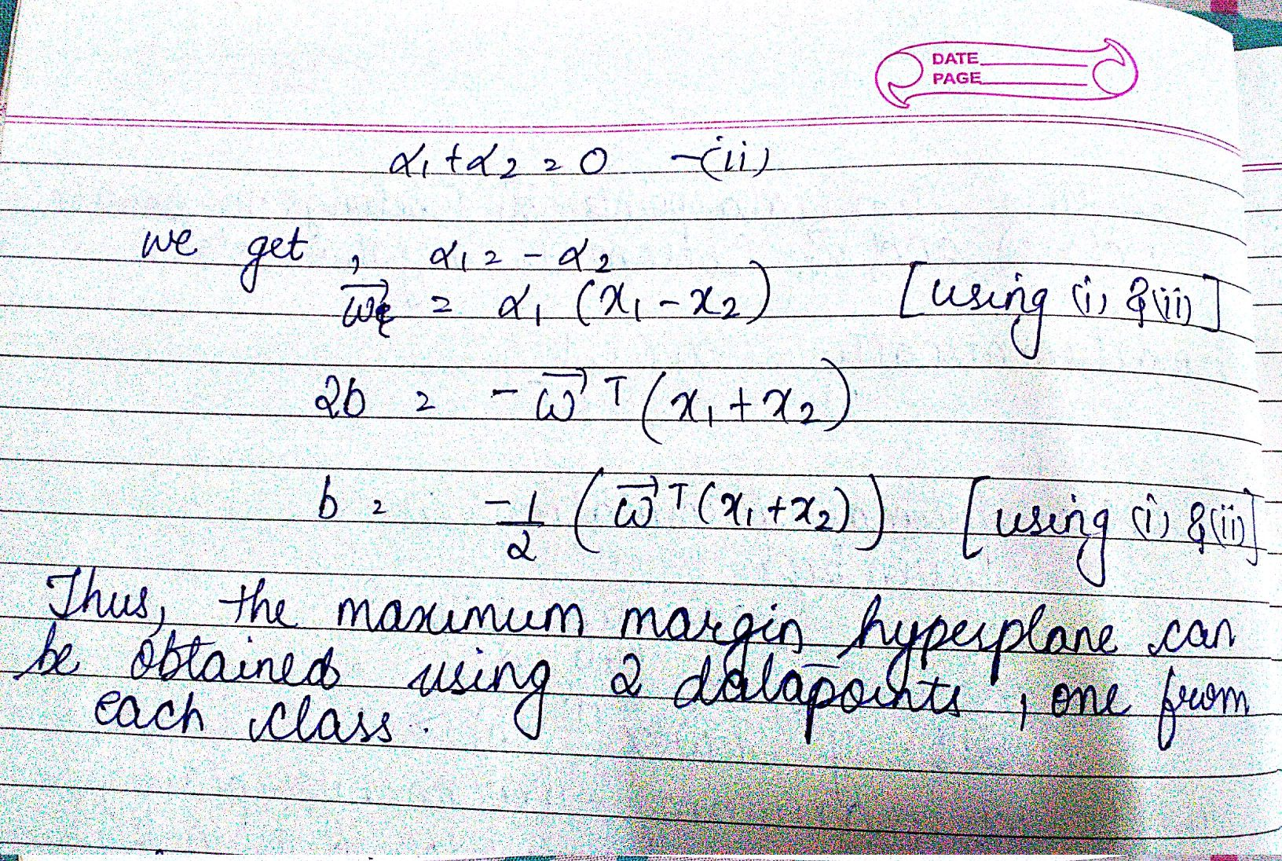

3. Consider​ ​ the​ ​ hard-margin​ ​ SVM.​ ​ Find​ ​ the​ ​ maximum​ ​ margin​ ​ for​ ​ the​ ​ following​ ​ case.
How​ ​ does​ ​ the​ ​ size​ ​ of​ ​ maximum​ ​ margin​ ​ changes​ ​ if​ ​ we​ ​ remove​ ​ X7 ​ ​ from​ ​ the​ ​ training
dataset.

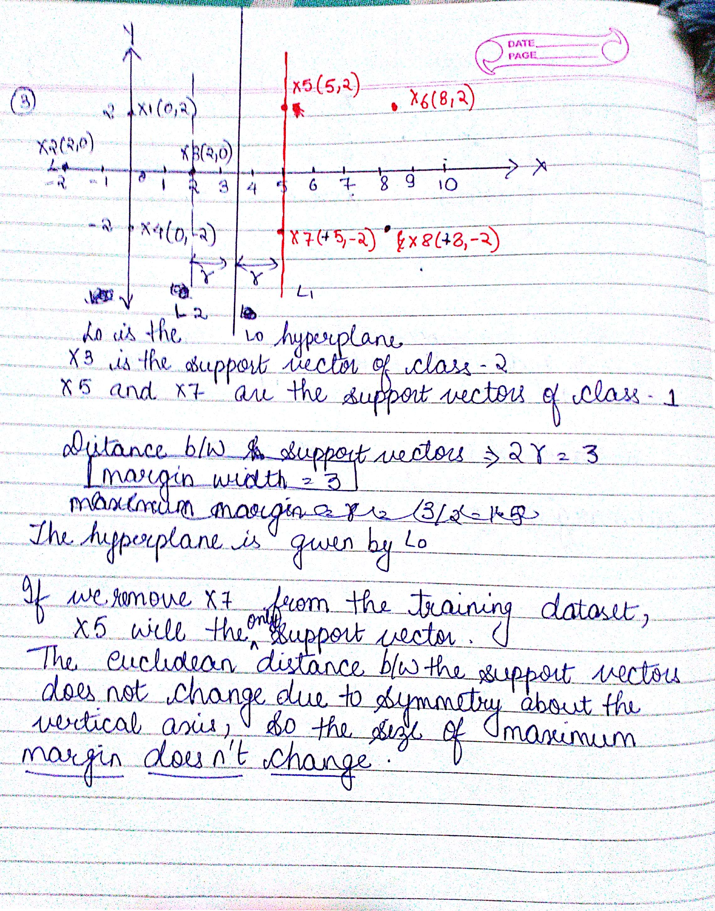

4. Can​ ​ you​ ​ model​ ​ the​ ​ XOR​ ​ operator​ ​ using​ ​ an​ ​ SVM?​ ​ Justify.



